[Date]
[Recipient’s Name]
[Designation]
[Organization]
[Address]
Dear [Title/Name],

INVITATION TO PARTICIPATE IN THE KWARA AI SUMMIT 2025
We are pleased to introduce the Kwara AI Summit 2025, a landmark event convened to accelerate conversations and collaborations around artificial intelligence, innovation, and digital transformation in Nigeria and across Africa.
Hosted at the Ilorin Innovation Hub, the Summit brings together leading experts, innovators, startups, and policymakers to explore how AI can drive inclusive growth across governance, education, entrepreneurship, and sustainable development.
We are delighted to invite you to be part of this transformative experience — as a [speaker/partner/exhibitor/participant] — contributing to a shared vision of positioning Kwara State as a leading hub for responsible AI and emerging technologies.
Further details about the Summit, including agenda, sessions, and participation opportunities, will be shared with you shortly.
Thank you for considering this invitation. We look forward to your positive response and to welcoming you to Ilorin for this milestone event.
Yours sincerely,
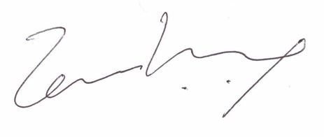
Temi Kolawole
Managing Director
Ilorin Innovation Hub
Convener, Kwara AI Summit 2025
summit@kwara.ai | +2348155555222 | kwara.ai

